**Setting up the environment (Python = 3.8)**

This module provides instructions for setting up a virtual environment using conda libraries. While each user may have a different version of Python installed on their machine, in a real-world scenario, a project will be built on specific libraries. To address this problem, the following module outlines how to set up the required Python version before starting any project locally.

1. Create a new working directory in Visual code

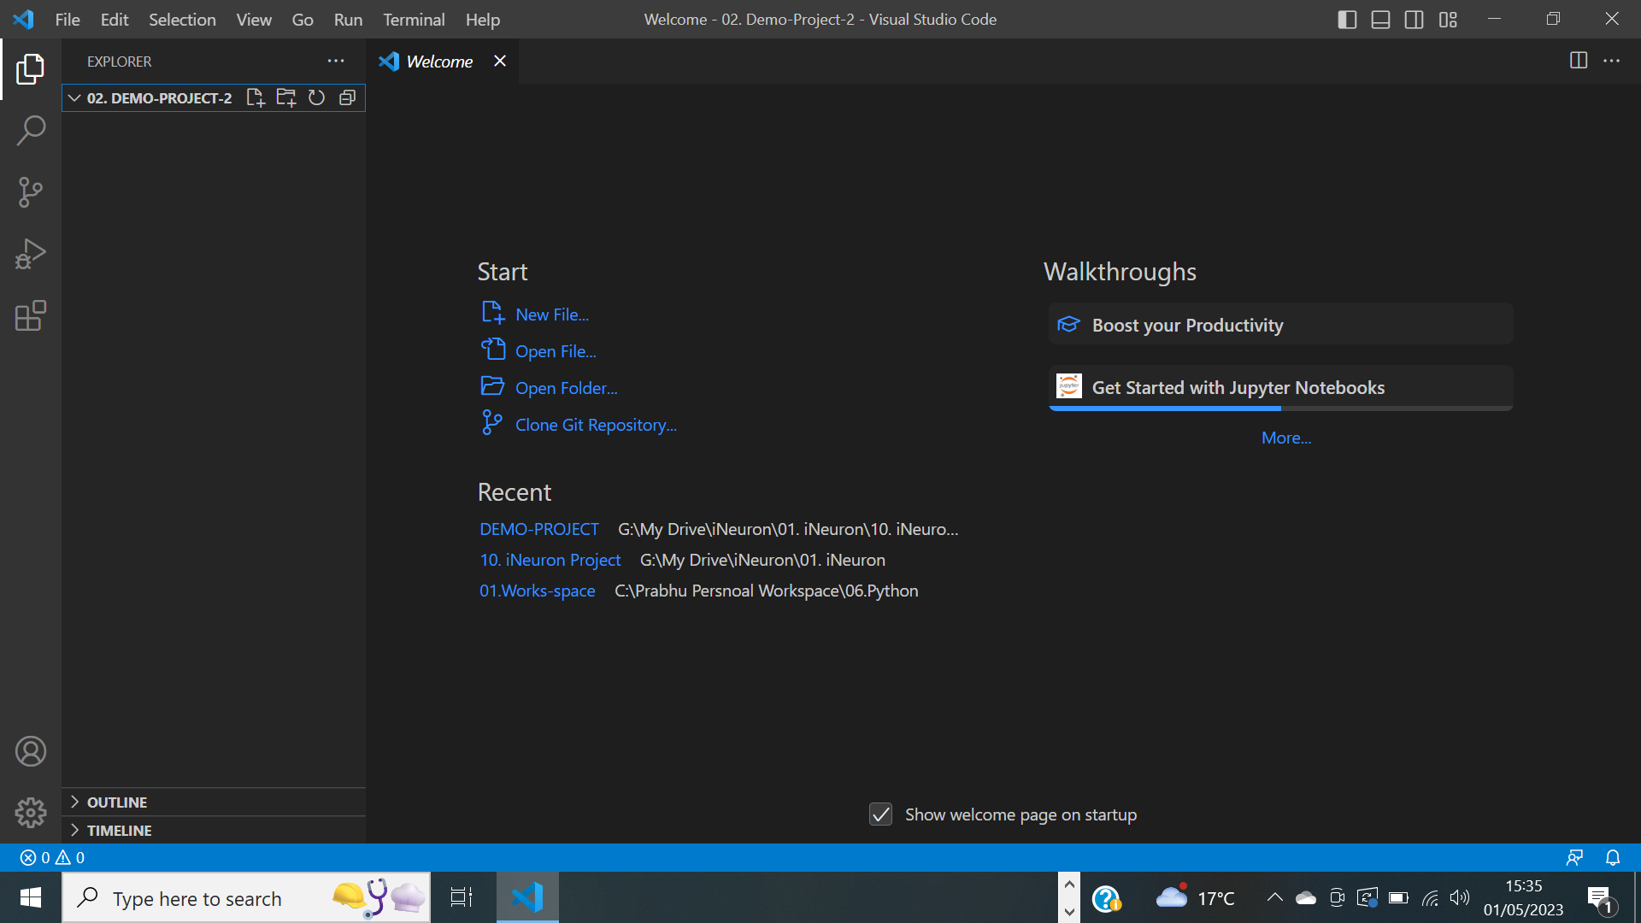

1. Open a new terminal and select the command prompt

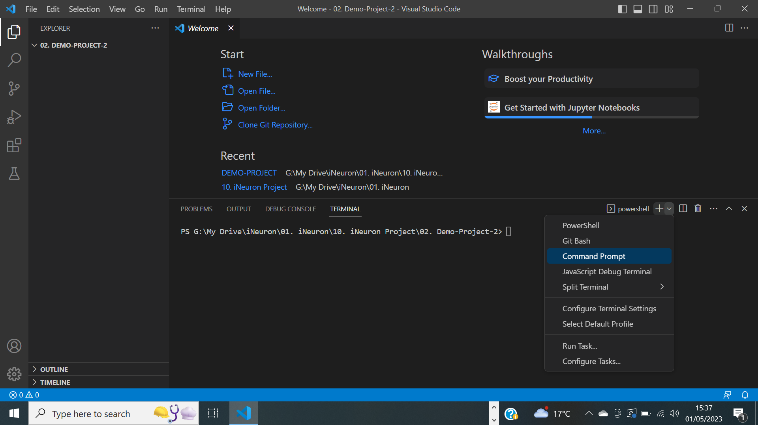

It will display as below for the base conda environment

If not displayed, make sure to install the anaconda in your local

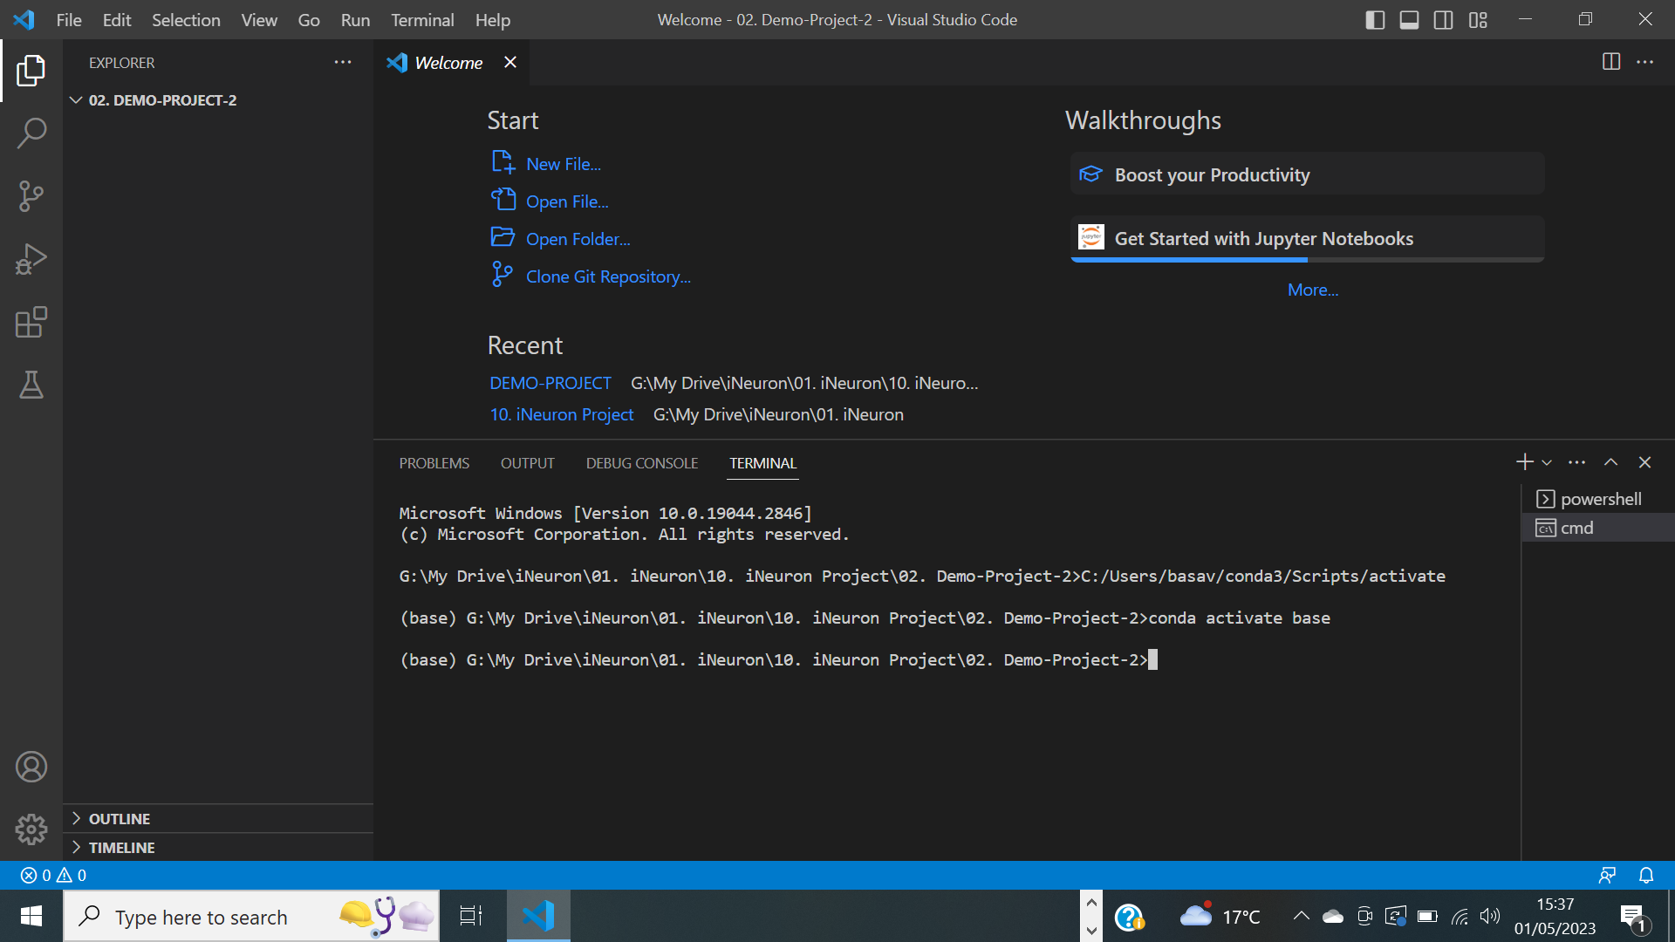

3) execute the below command in the terminal

conda create -p venv-demo-project2 python=3.8 ( this virtual environment uses the python 3.8 version)

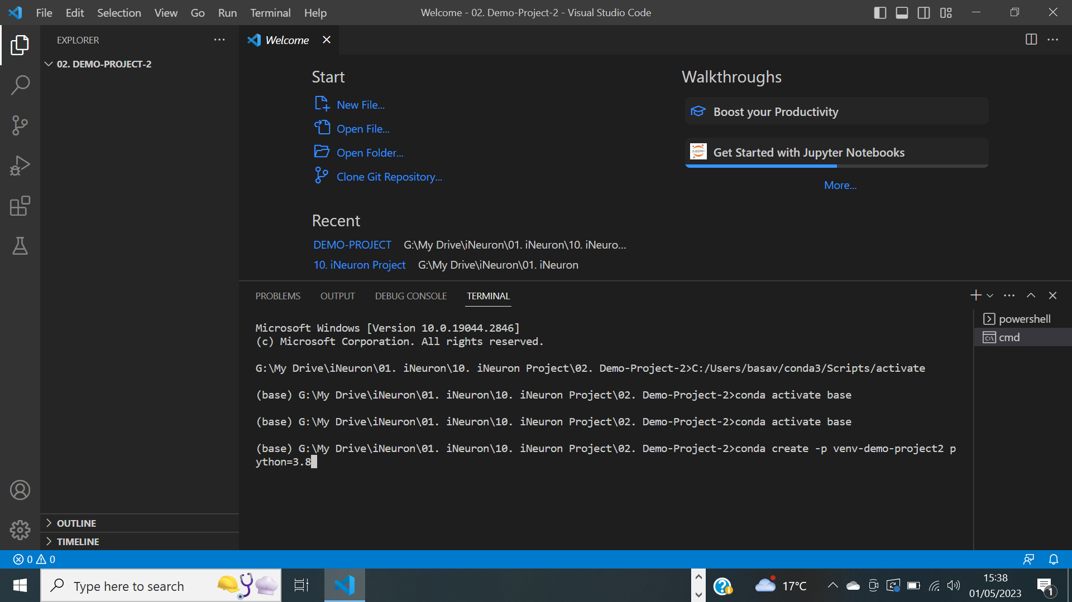

Hit Y

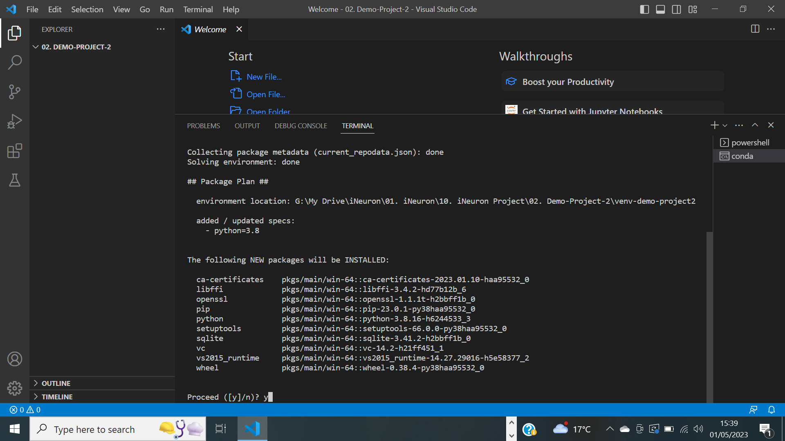

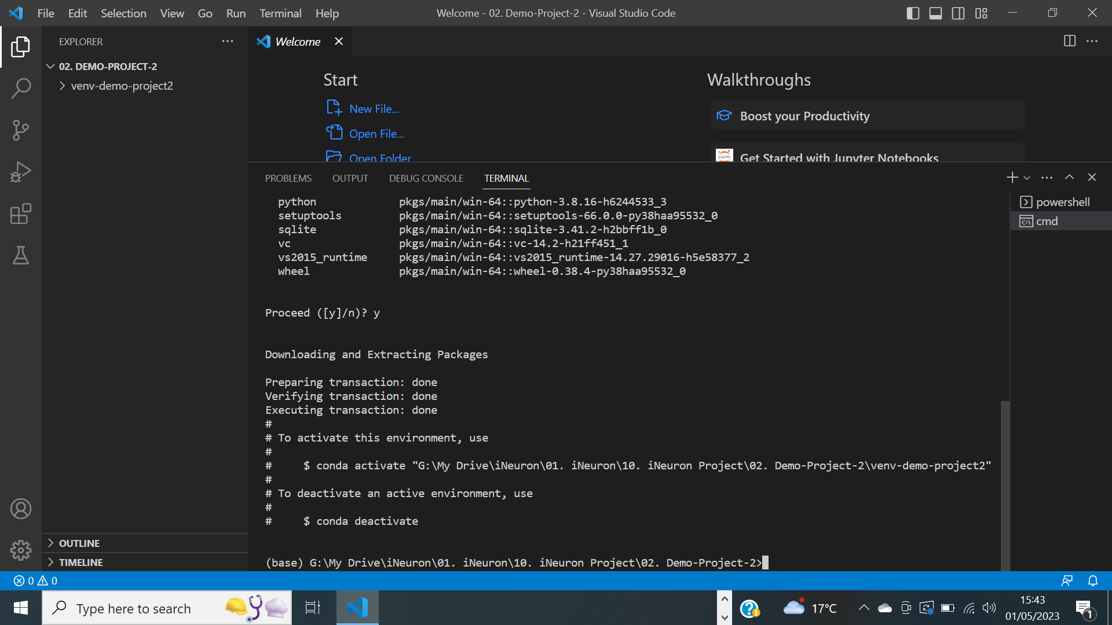

Activate the virtual environment by executing the following -

conda activate "G:\\My Drive\\iNeuron\\01. iNeuron\\10. iNeuron Project\\02. Demo-Project-2\\venv-demo-project2"

After running the conda activate command the base will change to the workspace which you created

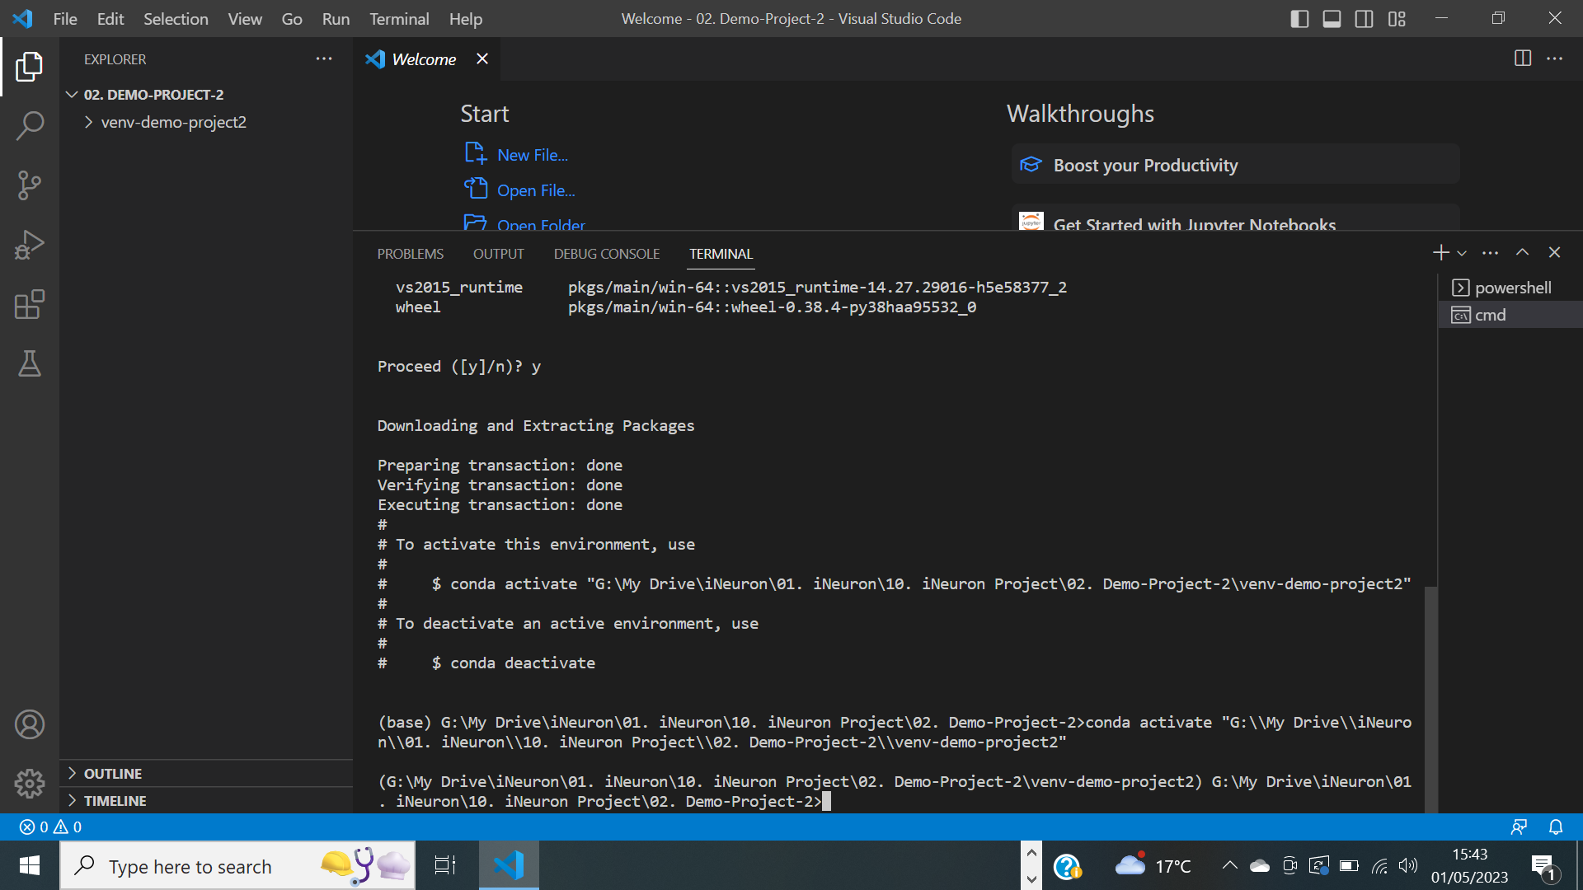

4) Create the following files and folder

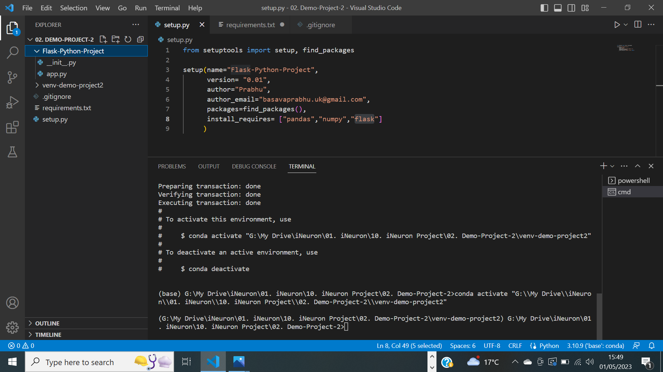

__init__.py -> Create this file if you wish to turn your workspace into a module so that it can be distributed onto Conda or PyPI similarly to Pandas or Numpy.

.gitignore -> Mention in this file any files or folders you don't want to commit to Github.

Setup.py ->Write the following code to specify the name of the module and its creator.

from setuptools import setup, find_packages

setup(name="Flask-Python-Project",

version= "0.01",

author="Prabhu",

author_email="basavaprabhu.uk@gmail.com",

packages=find_packages(),

install_requires= ["pandas","numpy","flask"]

)

requirement.txt -> specify the libraries you want to import for your project

-e . -> details to execute the this file and install the required libraries 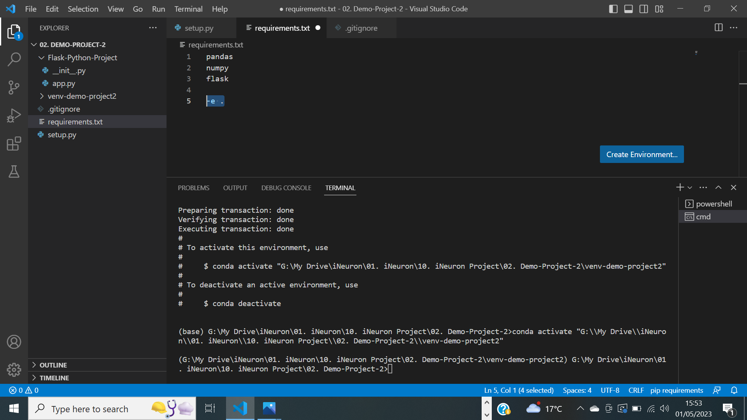

5. Run the following command

python setup.py install -- this will create the .egg-info folder

6. pip install -r requirements.txt

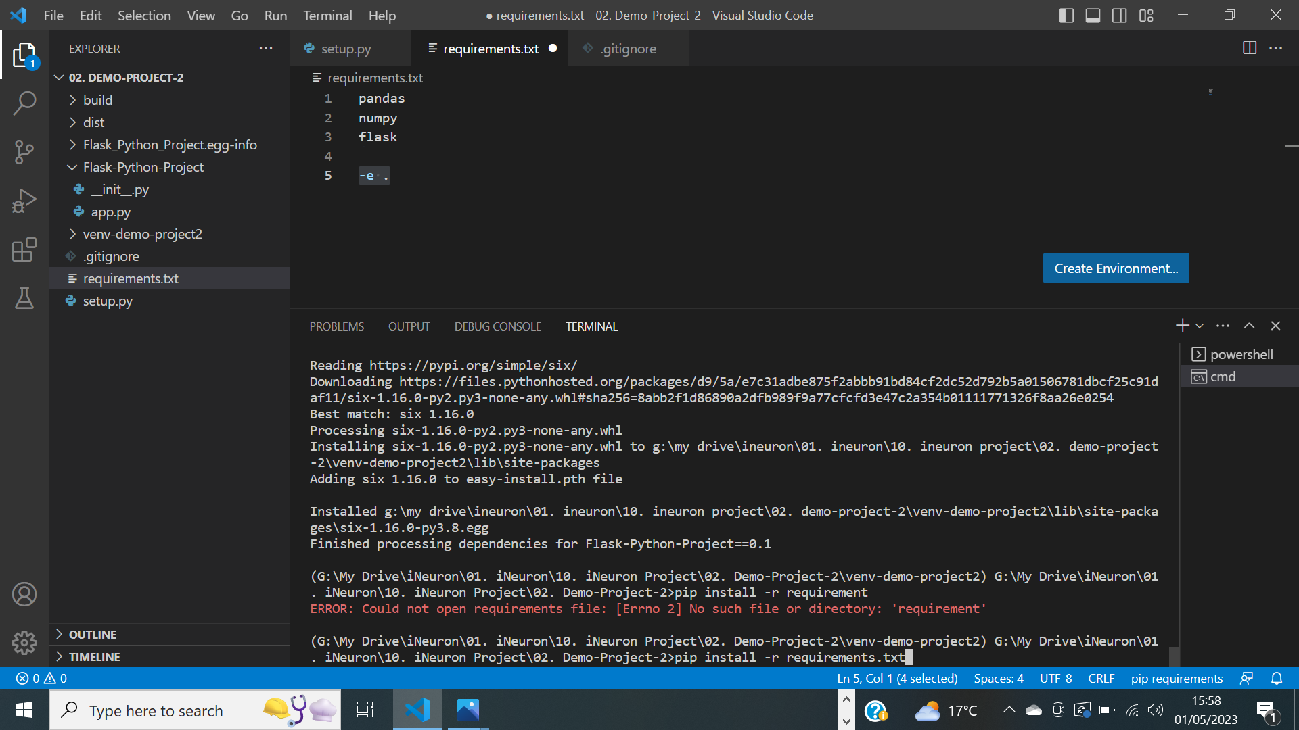

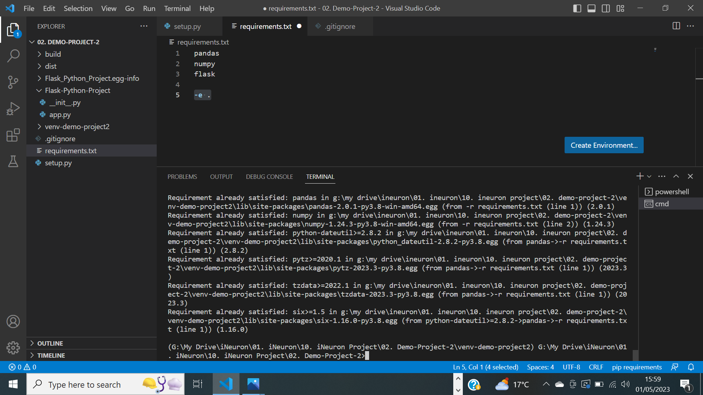

7. Run conda env list to verify the virtual environment created

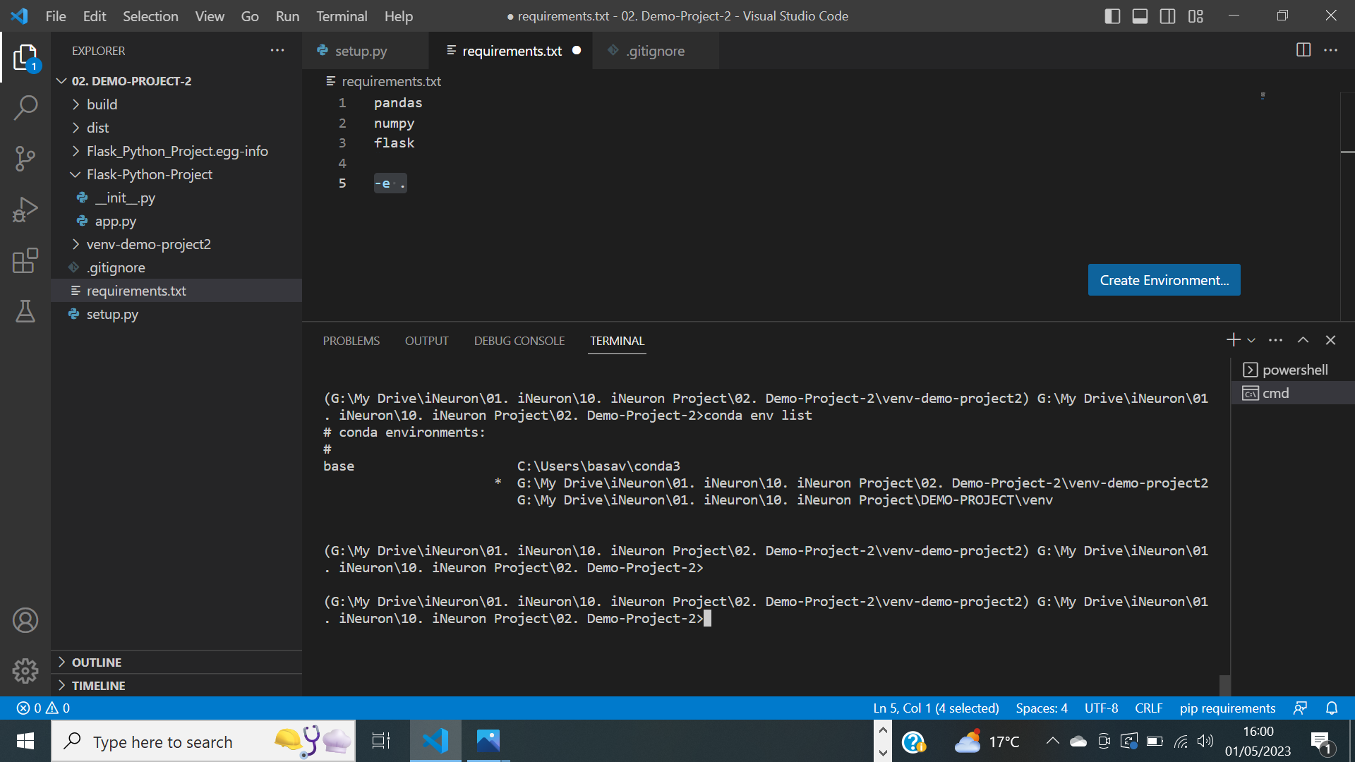

8. To run the ipynb file, select your environment

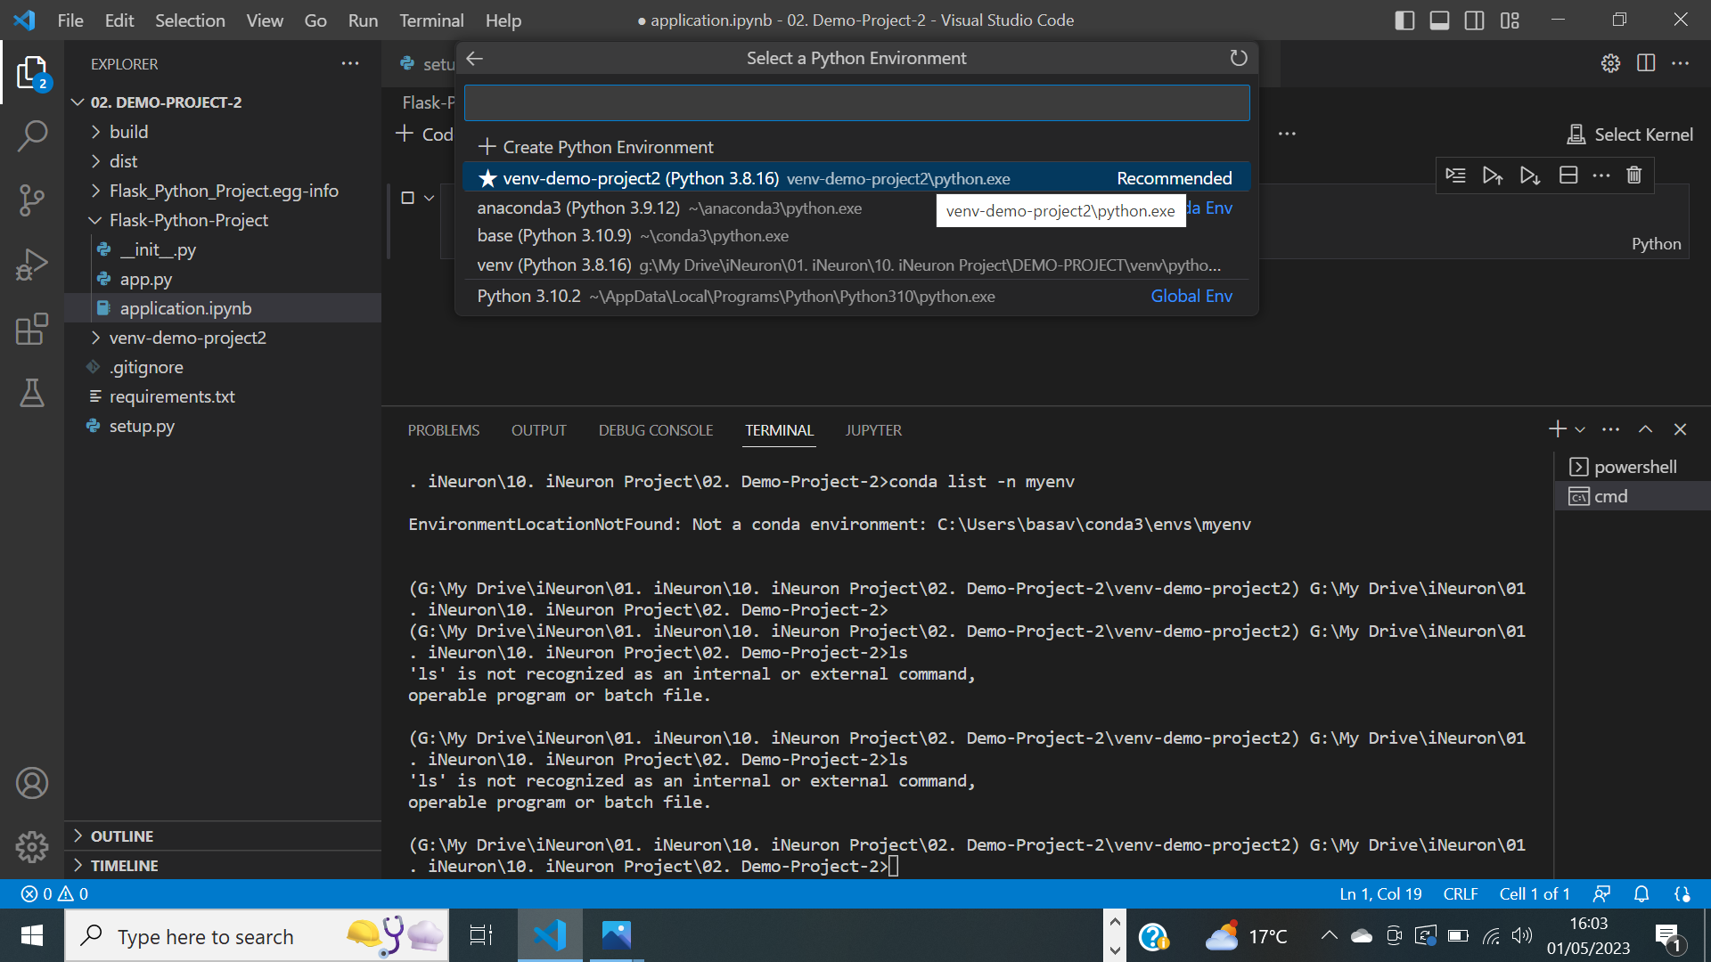

Run the following command

**conda install -p “G:\\My Drive\\iNeuron\\01. iNeuron\\10. iNeuron Project\\02. Demo-Project-2\\venv-demo-project2” ipykernel --update-deps --force-reinstall'**

**And you can run the ipynb file like Jupyter Notebook under your environment (in this case python 3.8 version)**

